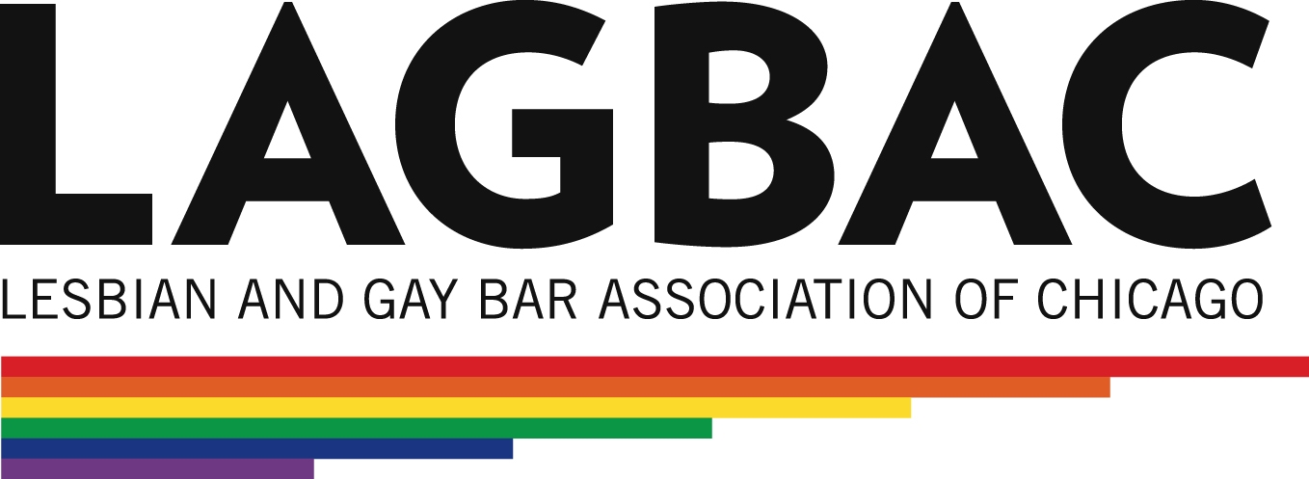
The Lesbian and Gay Bar Association of Chicago Foundation
2013 Summer Scholarship Grant Application
The Lesbian and Gay Bar Association of Chicago (LAGBAC) is a professional, not for profit organization comprised of judges, attorneys, law students, and affiliated legal professionals that relies on the energy of its members to be successful. The LAGBAC Foundation is a charitable, 501(c)(3) organization that raises funds in order to, among other things, assist law students who desire to work for a public interest organization. To this end, the LAGBAC Foundation awards grants to law students attending an accredited law school in Illinois (and in some cases, out of state) who will be working for a qualified public interest organization. The number of LAGBAC Foundation scholarship grants awarded depends on, among other factors, the result of the Foundation’s fundraising efforts and the number of qualified applicants.
All scholarship grants will be awarded by the LAGBAC Foundation Board of Directors. The Foundation will award scholarship grants ranging from $3,000.00 to $4,000.00 to support full-time, summer employment with a qualified public interest organization. Scholarship grant recipients will be required to complete 300-400 hours over a minimum 10 week period. LAGBAC Foundation scholarship grants may be used to supplement other funding received for work above and beyond the required 300 hours; however, you must disclose any other funding sources and preference will be given to students who lack other dedicated funding for summer work.
Student Eligibility:
- The applicant must be a student attending an accredited Illinois law school;
- The applicant must commit to complete between 300 and 400 hours over the course of a minimum 10 weeks during the 2013 summer break (roughly June through August); and
- First, second, and third year full-time and part-time students are encouraged to apply and are given equal consideration.
Factors Considered:
- The extent to which the applicant has participated in activities aligned with LAGBAC’s goals and mission;
- The position obtained by the applicant (or intended position) and the importance of the unmet public legal need to be addressed by applicant;
- The quality of supervision, including, but not limited to, training, guidance, and learning experience;
- The applicant’s demonstrated commitment to public service or public interest law; and
- The quality of the applicant’s application.
Qualified Organization:
An applicant must, before applying, apply to or secure a position at a qualifying public interest organization in the Chicagoland area that meets the following standards (you will need to turn in a copy of that application along with this application):
- The proposed organization must utilize the legal skills of the applicant;
- The applicant will be supervised, preferably by a licensed attorney; and
- The position must be consistent with LAGBAC's goals and would otherwise be unfunded. Public interest work includes, but is not limited to, legal assistance organizations, private nonprofit organizations, government agencies, and private, pro bono projects. The LAGBAC Foundation does not fund employment on political campaigns or with judges.
Suggested organizations include, but are not limited to: Lambda Legal, AIDS Legal Council of Chicago, American Civil Liberties Union of Illinois LGBT Project, AIDS Foundation of Chicago, Howard Brown Health Center, Heartland Alliance/National Immigrant Justice Center and Equality Illinois. If you are interested in applying but are uncertain which organization to approach or how to approach them, contact Jeremy Gottschalk, at jgottschalk@lagbac.org.
Application:
- Current resume, highlighting activities in which you have participated that are consistent with LAGBAC’s mission and goals;
- Personal statement (no more than three single-spaced pages);
- Response to the following statement (no more than three single-spaced pages): The role that attorneys play in the LGBT rights movement;
- Letter of recommendation from a practicing attorney or law school professor/administrator;
- Either: (a) A letter from a representative at a qualified organization where applicant has obtained summer employment or (b) a copy of your application to the qualified organization where you intend to work; and
- Applicant must be a member of LAGBAC and may be asked to participate in a brief interview.
At the end of the summer, the applicant and the qualified organization will be responsible for jointly preparing a brief report summarizing the experience. The applicant will also be responsible for volunteering at least one LAGBAC Foundation or LAGBAC-sponsored networking, community service, or educational event.
The application must be received by LAGBAC at the address below no later than the close of business March 8, 2013. The scholarship grants will be awarded shortly thereafter and the winner will be recognized at the LAGBAC Brunch on April 14, 2013, at Bin 36 in Chicago, Illinois.
LAGBAC Foundation Application
P.O. Box 64933
Chicago, Illinois 60664-0933
Questions concerning the application and the potential eligibility of students and/or organizations should be directed to Jeremy H. Gottschalk at jgottschalk@lagbac.org.

